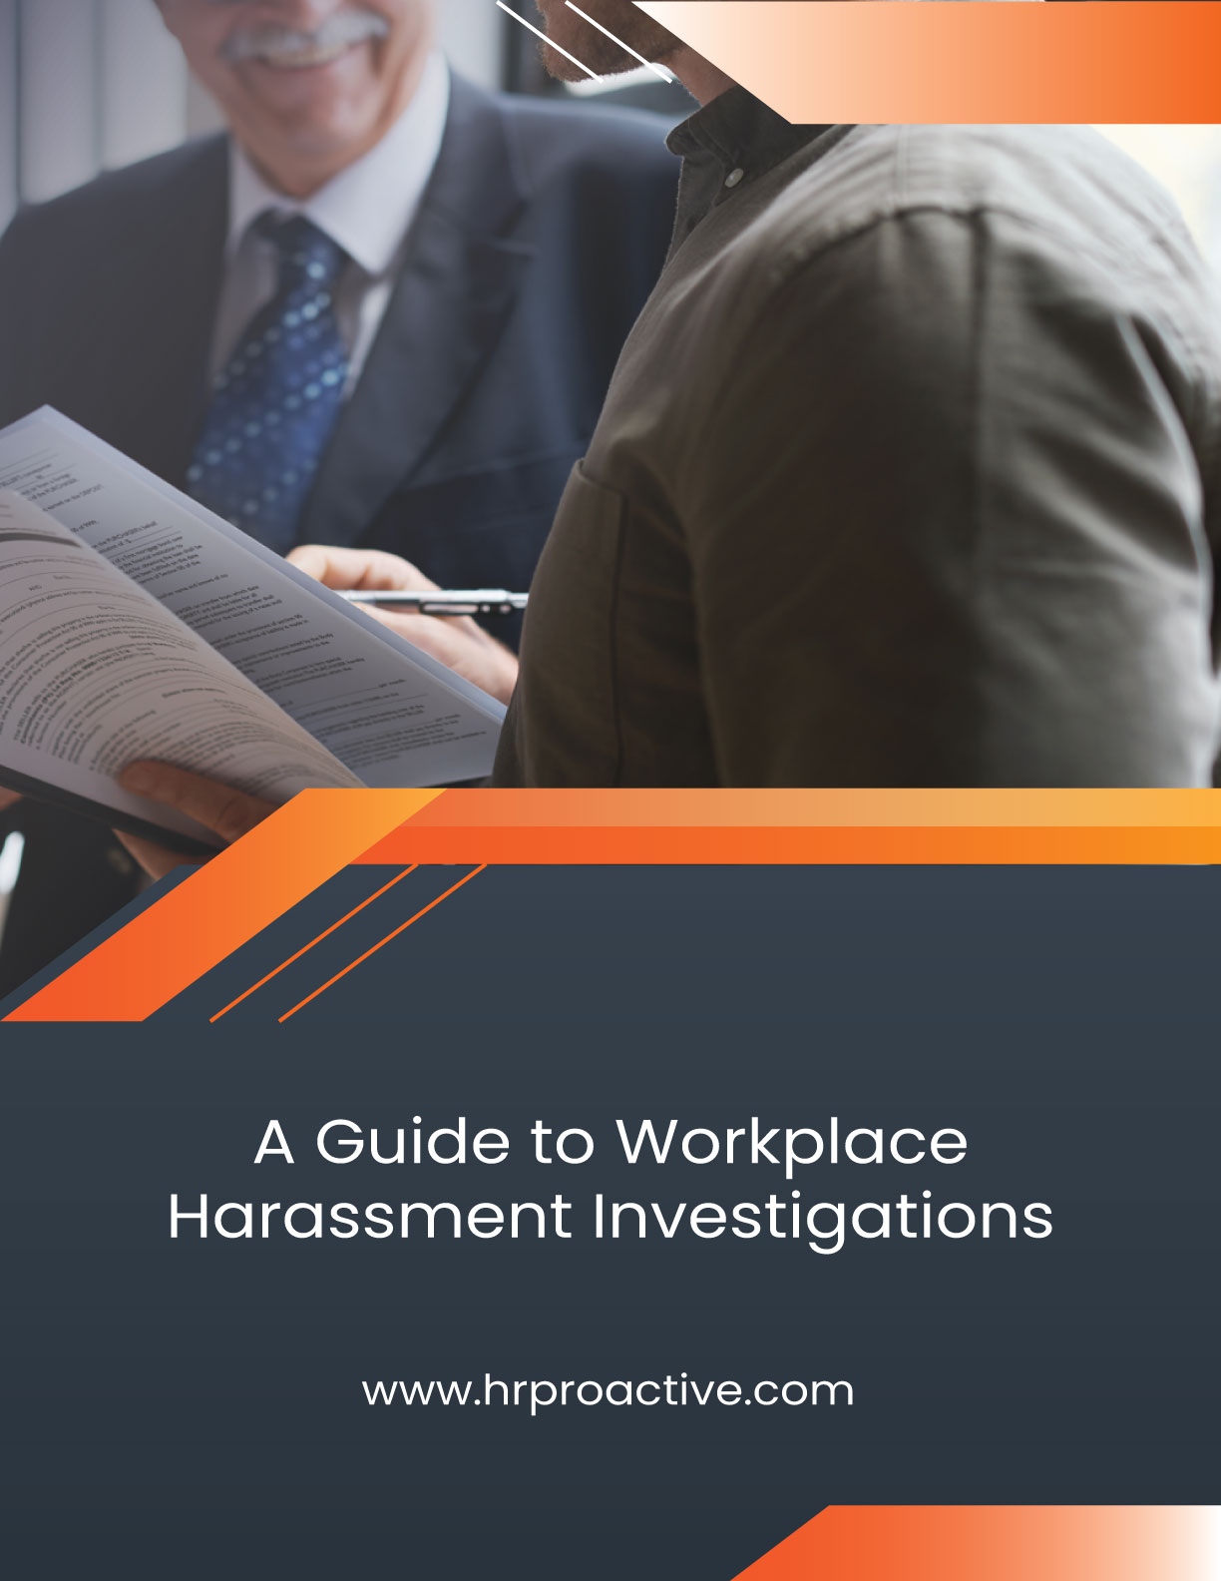
Table of Contents
INTRODUCTION 2
WORKPLACE HARASSMENT 2
Legislation 2
Sexual Harassment 2
The Duty to Act With “Due Diligence” 3
Workplace Harassment Policy 3
RECEIVING AND ASSESSING A COMPLAINT 3
DEFINITIONS 3
Burden of Proof 4
Prima Facie 4
EVIDENCE 4
Types of Evidence 5
Investigation File 5
Is it Harassment? 5
ASSIGN AN INVESTIGATOR 5
Investigator Best Practices 5
THE INVESTIGATION 6
The Investigation Plan (Pre-Investigation) 6
CONDUCTING THE INVESTIGATION 7
Gathering Evidence 7
The Interviews 7
Review Evidence 8
Investigation Report 8
Background 8
Investigation Scope and Methodology 8
Investigative Process 8
Complaint(s) Statement 9
Respondent’s Reply 9
Evidence 9
Analysis/ Findings 9
Conclusion 9
Communicate the Outcome 9
Corrective Actions 10
Training and Prevention 10
Summary 10

INTRODUCTION
Managing workplace harassment complaints can be complex as they involve sensitive issues that impact both the organization and its employees. Poorly managed complaints can lead to costly, time-consuming issues, damaging productivity, morale, and legal consequences.
This guide provides an overview of harassment investigations, including topics like evidentiary matters, legal standards, investigative techniques, and the overall process.

WORKPLACE HARASSMENT

Legislation
Ontario Human Rights Code (OHRC)
The OHRC defines workplace harassment as any unwelcome conduct based on protected grounds, including race, sex, disability, age, and others. Harassment can create a hostile or poisoned work environment.
Occupational Health and Safety Act (OHSA)
The OHSA broadly defines harassment as vexatious conduct known or ought to be known to be unwelcome. It includes behaviour that isn't necessarily targeted at a specific person, such as general disrespectful behaviour.
Examples of Harassment
- Preventing someone from expressing themselves, making unwanted sexual advances, or isolating individuals.
- Discrediting someone through malicious gossip, humiliating them, or compelling them to do tasks that belittle them.
Poisoned Work Environment (PWE)
- A PWE is created when harassment or discrimination makes the workplace intolerable. It can be a single event or part of a pattern. Factors include whether the behaviour is unavoidable and the effect on the work environment.
What Doesn’t Constitute Harassment
- Normal management functions such as performance reviews or discipline.
- Workplace conflict or stress, unless it is unresolved and escalating into harassment.

Sexual Harassment
Sexual harassment is covered by both the OHRC and OHSA. It includes unwelcome advances or comments, often by someone in authority, and includes gender-related comments and actions that are not explicitly sexual.
Human Rights Code and Sexual Harassment
Sexual harassment includes conduct based on sex, sexual orientation, gender identity, and gender expression. It also includes sexual solicitations by someone in authority.
Health and Safety Act
The OHSA defines workplace sexual harassment similarly to the OHRC and also includes non-sexual comments related to sex or gender, sexual jokes, or pornography.

The Duty to Act With “Due Diligence”
Employers can be held legally responsible for the discriminatory and harassing behaviour of managers, supervisors, and employees and for failing to address harassing behaviour directed at employees by customers, contractors, suppliers, and the public.
An employer can demonstrate due diligence by:
- Create and enforce a human rights policy with workplace education and training.
- Develop internal investigation procedures for human rights complaints.
- Resolve human rights matters promptly and take steps to prevent recurrence.
- Ensure corporate policies and conduct comply with the Human Rights Code.
- Raise awareness of the policy and rights under the Human Rights Code through education and training.
- Resolve discrimination and harassment complaints quickly, fairly, and sensitively.

Workplace Harassment Policy
A workplace harassment policy ensures all employees know their rights and responsibilities and provides the framework for conducting thorough and impartial internal harassment investigations.
A workplace harassment policy should include:
- A clear and explicit definition of harassment, consistent with the Ontario Human Rights Code and the Occupational Health and Safety Act.
- Expectations for acceptable behaviour.
- The potential consequences of engaging in harassment.
- Process for employees to report incidents of workplace harassment (how and where). Ensure there is more than one way for employees to report incidents of harassment.
- How incidents or complaints will be investigated.
- How the results of the investigation will be communicated to the complainant.
- Provisions to protect employees who report incidents of harassment from retaliation.

RECEIVING AND ASSESSING A COMPLAINT
Upon receiving a harassment complaint, a neutral authority should acknowledge it respectfully, confirming the organization's commitment to addressing the issue. The merits of the complaint will be determined after the respondent(s) have replied, evidence, including witness statements, is gathered, and the investigation is complete.
Timeliness
OHSA Requirement: Promptly initiate an investigation upon receiving a complaint. Delays can be perceived as indifference, and timely action is crucial for minimizing potential harm.
The respondent should be promptly informed of the complaint, the investigation process, and relevant policies. First, efforts should be made for informal resolution; if unsuccessful, an administrative investigation may be initiated.

DEFINITIONS
Complainant: the person(s) who has made a complaint or has accused someone of misconduct.
Respondent: the person(s) who have had a complaint(s) made against them.
Witness: someone who sees, knows, or vouches for something.
Evidence: something that proves or disproves an alleged fact.
Witness Evidence: a person’s statements or testimony gathered by interview or written statement.
Misconduct: any inappropriate action, offence, or professional fault committed knowingly or deliberately by a person working for an employer. Misconduct occurs when an employee violates the obligations set out in their employment contract.

Burden of Proof
Unlike a criminal trial, where the standard is "beyond a reasonable doubt," a workplace investigation does not require the same level of certainty.
The standard of proof in a workplace harassment investigation is often referred to as the "balance of probabilities." This means that the evidence must establish that it is more likely than not that the alleged harassment occurred.

Prima Facie
In the context of a workplace harassment investigation, "prima facie" refers to the initial evidence or the case presented by the complainant that, on its face, appears to be sufficient to support the allegations. “Prima facie” is Latin for "at first sight" or "on its face." Establishing a prima facie case means that, based on the evidence provided, there is a reasonable belief that the alleged harassment may have occurred.
Impartiality and Fairness
OHSA Requirement: An investigator must be impartial and objective throughout the process. They must avoid any conflicts of interest that could compromise the fairness of the investigation.
Both parties to the workplace harassment complaint:
- Are entitled to a timely, neutral, and unbiased investigation.
- Are entitled to representation (union)
- Have the right to know the outcome.
- Have the right to be heard and present evidence.
- The right to appeal or reconsideration.
- The respondent named the workplace harassment complaint:
- Has the right to know details of the complaint (ex. the complainant, particulars).
Confidentiality
OHSA & Human Rights Code Requirement: Maintain confidentiality to the extent possible throughout the investigation process. This includes protecting the identity of the complainant and any witnesses and ensuring that information is disclosed on a need-to-know basis.

EVIDENCE
Evidence is admissible information that proves the facts in question, primarily consisting of statements from the parties and witnesses. Opinions and character assessments are not evidence but inferences. The investigator's role is to gather and assess evidence to determine if harassment occurred, understanding how to interpret and weigh different types of evidence.

Types of Evidence
Direct Evidence: Directly leads to the facts in issue, including eyewitness statements and physical evidence (e.g., photos, videos, documents). It is the strongest form of evidence.
Indirect Evidence: Supports findings by establishing facts or timelines but is less persuasive than direct evidence.
Similar Fact Evidence: This shows similar conduct by the person involved, such as a past employee's statement of harassment by the same individual. It is relevant, particularly in sexual harassment cases, but not as strong as direct evidence.
Hearsay: Statements made by someone not directly involved, offered for its truth. Hearsay is weaker than direct evidence, and whenever possible, the investigator should gather direct evidence.
Expert Evidence: Opinions from recognized experts, such as those explaining the effects of harassment, can be used but should be considered carefully.

Investigation File
The investigator will maintain a file by carefully recording when and how evidence is received.
In the file, retain:
- all interview notes.
- all communications with witnesses, the complainant, and the respondent.
- all written witness statements.
- all documents that relate to the allegation.
- all documentation notifying appropriate parties of the investigation results.
- Keep the investigation file in a secure location separate from personnel files.
Documentation
OHSA & Human Rights Code Requirement: Document the entire investigation process, including interviews, findings, and any corrective actions taken. A well-documented process serves as evidence of due diligence and compliance with legal requirements.

Is it Harassment?
At this stage, the focus is not on proof but on whether the complaint, if proven, would violate harassment laws. Judgements should not be based on the character of the complainant or respondent. If the complaint could be a violation, proceed with an investigation. If not, consider alternative actions, such as mediation, especially if the issue involves a technical dispute without discrimination or bullying.
Let’s look at the person responsible for executing the investigation– the investigator.

ASSIGN AN INVESTIGATOR

Investigator Best Practices
- No personal or professional ties to the parties involved.
- Have appropriate training and expertise in conducting harassment investigations.
- Clearly outline the steps of the investigation process to all involved parties.
- Treat all parties equally. Avoid any appearance of favouritism or bias.
- Communicate the importance of confidentiality to all involved parties.
- Initiate the investigation promptly.
- Conduct a thorough investigation and approach the investigation with objectivity, ensuring that all aspects of the complaint are examined.
- Ensure that the complainant has the chance to present their side of the story and provide any relevant evidence or witnesses.
- Use neutral and objective language. Avoid assumptions or language that may imply guilt or innocence.
- Identify and manage potential conflicts of interest to maintain impartiality and credibility.
- Maintain thorough, consistent, and well-documented records of all aspects of the investigation.
Designated Investigator
OHSA Requirement: Designate a competent, impartial, and knowledgeable individual to conduct the investigation. This person could be internal (HR personnel) or external, but they should be capable of conducting a thorough and unbiased inquiry.

THE INVESTIGATION
Several important considerations must be made when conducting an internal investigation:
- Maintenance of neutrality and impartiality
- Confidentiality
- Maintenance of an investigation file and/or documentation
- Parties’ right to representation (if applicable), translation and accessibility
- Periodic review – maintaining records/statistics. Is this a situation that needs to be revisited after a specified period?
- Timeliness. Is the investigation taking place within a realistic timeframe?
- Communicating results of investigation: to whom should the results be communicated?
- Credibility and Reliability
- External investigations (OHRC, Police, Union). Are external investigations required, or is there a possibility of an investigation by an external agency?

The Investigation Plan (Pre-Investigation)
- Obtain the complaint (initial complaint made by the complainant).
- Investigation focus (allegations, particulars).
- Inform the appropriate parties.
- Compile a witness list.
Issue – What is the complaint about?
Fact – What facts have been or need to be gathered? How?
Evidence – What evidence is available?
Identify the Issues
- Was the complainant harassed based on a ground under the Ontario Human Rights Code (e.g., race, sex, disability, age)?
- Did the complainant experience harassment as defined by the Ontario Occupational Health and Safety Act (OHSA)?
- Is the employer compliant with the OHSA, including having harassment policies, providing training, and protecting employees from harassment?

CONDUCTING THE INVESTIGATION

Gathering Evidence
- Required evidence includes witness statements, especially from the complainant and respondent, detailing what, when, and where events occurred. Avoid opinion evidence.
- Documents, records, and emails provided by the parties or witnesses.
- The employer’s harassment policy and procedure, training records and any records of enforcing the policy and procedure, including discipline records if any.
- Open an investigation file.

The Interviews
Interviews with the complainant, respondent, and witnesses are crucial for gathering evidence. The complainant’s written complaint should be clarified and signed. The respondent is given a summary of the complaint and time to respond before the interview. Both parties’ positions, including relevant documents, are gathered.
Preparing for Interviews
Before interviews, the investigator reviews details of the allegations, responses, the parties’ positions, and relevant policies. Questions are prepared in advance, with flexibility for further probing.
Interview Location
Conduct interviews in a private, neutral location. If representatives or supporters are present, they should not answer questions or interfere, and the interview should pause if needed for private discussions.
Separate Interviews
If there are multiple complainants or respondents, they should be interviewed separately.
Interview Witnesses
Witnesses are identified based on written allegations and their potential to corroborate or refute the complainant's and respondent's accounts. They may offer crucial information that was missed or withheld. The investigator decides which witnesses to interview based on the material facts.
Begin with a polite introduction and reference your authority to conduct the interview. Document the location, date, time, and attendees. Start by asking about the subject's role, tenure, and relationships with the parties to establish rapport. Follow with questions directly related to the allegations.

Interview Tips
- Use plain language and remain neutral.
- Start with open-ended questions and practice active listening.
- Focus on the witness’s observations, not secondhand information.
- Probe deeper, if necessary, progressively asking for more specific details.
- End by asking, "Is there anything else you would like to add?" Consider a second interview if new facts arise.
Following the Interviews
Determine if a second interview is necessary—avoid over-investigating if sufficient material is available. Update the investigation file with details about evidence retention, including how and when the evidence was obtained. Consider confidentiality, security, and safety concerns.
Interview Record
Maintain records of all interviews. Digital audio recordings offer benefits like playback, track marking, and electronic storage, but may include distractions. Notes taken by hand or on a laptop are acceptable but should capture the witness’s exact words. If done well, these notes can be as accurate as audio recordings, especially if the subject reviews and signs them.
Other Issues
Witnesses may deny knowledge of incidents, especially if they are reluctant to implicate others. Explain the importance of full disclosure for the best outcome. Use caution before engaging outside witnesses, such as former employees or clients, and obtain senior management approval.
Collect Additional Evidence
It may be necessary to contact parties for clarification or rebuttal.

Review Evidence
Analysis
The investigator reviews all evidence (documentary, physical, and witness), identifies relevant policies or legislation, and applies the evidence to determine if there has been a policy or legal breach.

Investigation Report
The report summarizes the investigation and findings, typically provided to HR or management for communication with the relevant parties. The report must remain objective, written in plain language without modifiers, and maintain confidentiality by using roles or designations instead of names. Witnesses can be referred to as "Witness 1," "Witness 2," etc., if necessary.

Background
Outline the objective and scope of the investigation. This section may include background information about the organization. List the parties involved.

Investigation Scope and Methodology
Mandate or Terms of Reference
This section defines the investigation's scope, outlining the specific matter being investigated. Any additional issues or misconduct will be addressed separately.

Investigative Process
The investigator describes the methods used, ensuring the investigation followed workplace policies and procedures. This may include:
- A summary of the investigation process.
- Details on how interviews were conducted, including what was communicated to participants at the start. A standardized opening statement is essential to avoid coercion and ensure the process is an interview, not an interrogation.
- Information on union representation or other support, if applicable.
- A summary of confidentiality and anti-retaliation provisions was discussed with participants.

Complaint(s) Statement
The complainant’s statement is included, either in full or summarized. Allegations should be numbered for clarity.

Respondent’s Reply
The respondent's response is also included, summarized as needed, and listed alongside the corresponding allegations.

Evidence
- Documentary Evidence: List of collected documents, including names, version dates, and receipt details.
- Witness Statements: Summary of relevant witness testimony. Only witnesses with direct knowledge of the allegations are included; character witnesses are typically excluded.
Weighing the Evidence
Direct evidence, such as eyewitness testimony, is the strongest. Avoid making absolute judgments about credibility, like labelling someone a liar. However, if both direct and indirect evidence suggests the claim is untrue, reduce the weight given to it.
Do not assess credibility based on demeanour, such as assuming someone is lying because of hesitation. This is a judicial role, where credibility is assessed after observing the witness during direct and cross-examination.
Consider the relationships between witnesses and parties. Neutral witnesses’ testimony may carry more weight than that of someone with a close personal relationship who may have discussed the case beforehand.

Analysis/ Findings
- Summarize the allegations brought forward in the complaint, including details like the nature of the alleged harassment, the parties involved, and any other important dates or incidents.
- Evaluate evidence collected during the investigation, including witness statements, documentation, emails, or other relevant materials.
- Examine the credibility and reliability of the evidence to determine its significance to the investigation.
- Determine whether the reported behaviour aligns with the organization's harassment policies and procedures. Evaluate whether any breaches of policy occurred and whether the respondent named in the complaint is responsible for the reported behaviour and to what extent.

Conclusion
The conclusion restates a summary of the findings. It should be short and to the point. The conclusion will not have any new information; everything in the conclusion should already be stated in the report.
Unless specifically asked to do so, the investigator will not give their opinion about the situation or any suggestions as to what should happen to the parties involved. That remains up to the managers and human resources.

Communicate the Outcome
The investigation report is usually delivered to the person responsible for managing the harassment complaint. Whether the organization is obligated to share the report with the parties varies according to jurisdiction and internal policy. Investigation reports and outcomes are not typically shared with witnesses or others in the workplace for confidentiality reasons.
Reporting and Communication
OHSA Requirement: Report the findings to both the complainant and the alleged harasser, as well as any other relevant parties. Communication should be clear, respectful, and sensitive to the individuals involved.

Corrective Actions
Using the investigator’s findings, the organization/ person managing the complaint is responsible for deciding what corrective actions and follow-up measures are appropriate.
If harassment is substantiated, the person(s) responsible for managing the complaint must take prompt and appropriate corrective actions. This may involve disciplinary measures, additional training, or any other steps necessary to prevent recurrence.

Training and Prevention
After conducting a workplace harassment investigation, an organization should implement training and prevention measures to foster a safe and respectful work environment.
Training and Prevention
OHSA & Human Rights Code Requirement: Implement ongoing training programs to prevent harassment, educate employees on their rights and responsibilities, and create a culture of respect and inclusivity within the workplace.

Summary
We have reached the end of the guide. Hopefully, you now feel comfortable with your understanding of evidentiary matters, legal standards, and burdens of proof; gained solid investigative techniques, tips and procedures; and became more aware of such factors and considerations as credibility, confidentiality, and privacy throughout the harassment investigative process. We have included supporting documents and templates in the appendices for your use.

Appendix 1
Investigation Checklist
☐ Obtain and review policies and legislation, as applicable. Seek clarification of the scope of the investigation, if needed.
☐ Develop an investigation plan and provide a copy to the person responsible for managing the harassment complaint process.
☐ Review the written allegations and response to allegations.
☐ Meet with the complainant.
☐ Meet with the respondent.
☐ Explain the parties’ rights and responsibilities concerning the investigation.
☐ Record the parties’ statements and have them date and sign them.
☐ Meet with the witnesses.
☐ Record the witnesses’ statements and have them date and sign them.
☐ Review and update the investigation plan as needed.
☐ Proceed with additional interviews as needed.
☐ Visit the location of the alleged incident(s) of harassment, if relevant and appropriate.
☐ Provide the person responsible for managing the harassment complaint process with periodic verbal progress reports.
☐ Prepare the preliminary summary of facts and submit it to the person responsible for managing the harassment complaint process for onward submission and review by the parties.
☐ Obtain and review comments and submissions from the parties.
☐ Assess whether further investigation is warranted.
☐ Analyze the evidence.
☐ Prepare the investigation report and present it to the person responsible for managing the harassment complaint process.

